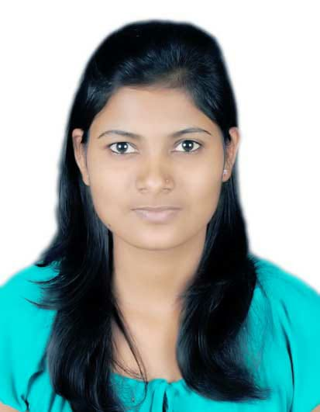

**Arti S Narwade Mobile : +91-9665204217**

**BE(Computer) E-Mail : [arti.narwade@gmail.com](mailto:arti.narwade@gmail.com)**

**Objective**

To work and grow in an environment where performance is rewarded with new challenges and responsibilities. Willing to prove myself to be an asset to the organization and the team by applying my technical and analytical skills.

**Summary**

* Good work ethics with good communication and interpersonal skills.
* Highly motivated, detail oriented, has ability to work independently and as a part of the team with Good Technical, Analytical and Communication skills.
* Ability to prioritize daily task and Complete task within time bound.
* Communicate effectively with client side , technical team and also work as effective member of team.
* Skilled in understanding requirements , presenting and convincing.

#### **Educational Qualifications**

* **MA**  in history from Savitribai Phule Pune University (SPPU).
* **BE** in Computer Technology from Dr. D. Y. Patil Institute of Engineering, Talegaon from SPPU with 62.00%.
* **Diploma** from JSPM with 80.14%.
* **S.S.C** from Genba Moza’s Smv with 79%.

**Certification**

* Manual Testing
* Automation Testing :- Selenium, QTP
* SQL

**Skills**

* Excellent understanding of SDLC , STLC, Waterfall model, Spiral model, Defect management
* Black and White box testing technique
* AGILE Methodology, Performance testing, Integration testing, Ad-hoc and monkey testing. Regression and Re-testing
* JAVA concepts : multitasking, Multithreading, Thread lifecycle, interface, exception handling, inheritance
* SQL commands : DDL,DML,DCL
* OOP’S concepts : object ,class, abstraction, polymorphism

**Project**

* Software project planner with ant colony optimization.
* Published paper on [www.ijarcsms.com](http://www.ijarcsms.com) SPP with ACO.

**Personal Profile**

Name : Arti Subhash Narwade.

Gender : Female

DOB : 09/06/1993

Nationality : Indian

Languages known : English, Marathi and Hindi.

Permanent Address : AP Khandale Tal. Shirur Dist- Pune(412209)

Contact no : 9665204217/7083104217

**Declaration**

I hereby declare that the information furnished above is true to the best of my knowledge. I would be pleased to provide any additional information if needed by you.

Date:

Place: PUNE (Arti S. Narwade)